CONTENTS

1. Safety Precautions Page 2
2. Switching On The Paintball Marker Page 3
3. Setting Up The Paintball Marker Page 4
4. Charging The Battery Page 8
5. Additional Functions Page 10
6. Paintball Detector Page 11
7. Velocity Adjustment Page 11
8. Semi-Auto Burst Mode and Automatic Mode Page 12
9. Gas Supply Page 13
10. Pressure Setting Page 13
11. Changing The Gas Cylinder Page 14
12. Changing The Solenoid Page 14
13. Maintenance Page 15
14. Troubleshooting Page 17
15. Product Specification Page 19

1. SAFETY PRECAUTIONS

- A paintball marker is not a toy. Please adhere strictly to all the safety instructions.
- Any improper use or incorrect procedure can cause injury or even death.
- All protective gears which are designed to protect players from the hazards of paintball must be worn during gameplay.
- Always measure the velocity of the paintball markers before gameplay. Ensure that the velocity is not more than 300 feet per second, or the maximum velocity that local laws allow.
- The paintball markers are designed to shoot at objects not less than 25 feet. Do not shoot at any person at close range.
- Keep the paintball marker switched off when not in use.
- Remove all the paintballs from the loader, feed port and chamber after games.
- Use .68 calibre paintballs only.
- Keep hands away from the feed port and chamber.
- Ensure barrel points to safe positions when not firing.
- Switch on the paintball marker only in game-play area.
- Relieve the paintball markers of all residual pressure when not in use.
- Consult and seek advice from professionals and experts when in doubt.

2. SWITCHING ON THE PAINTBALL MARKER

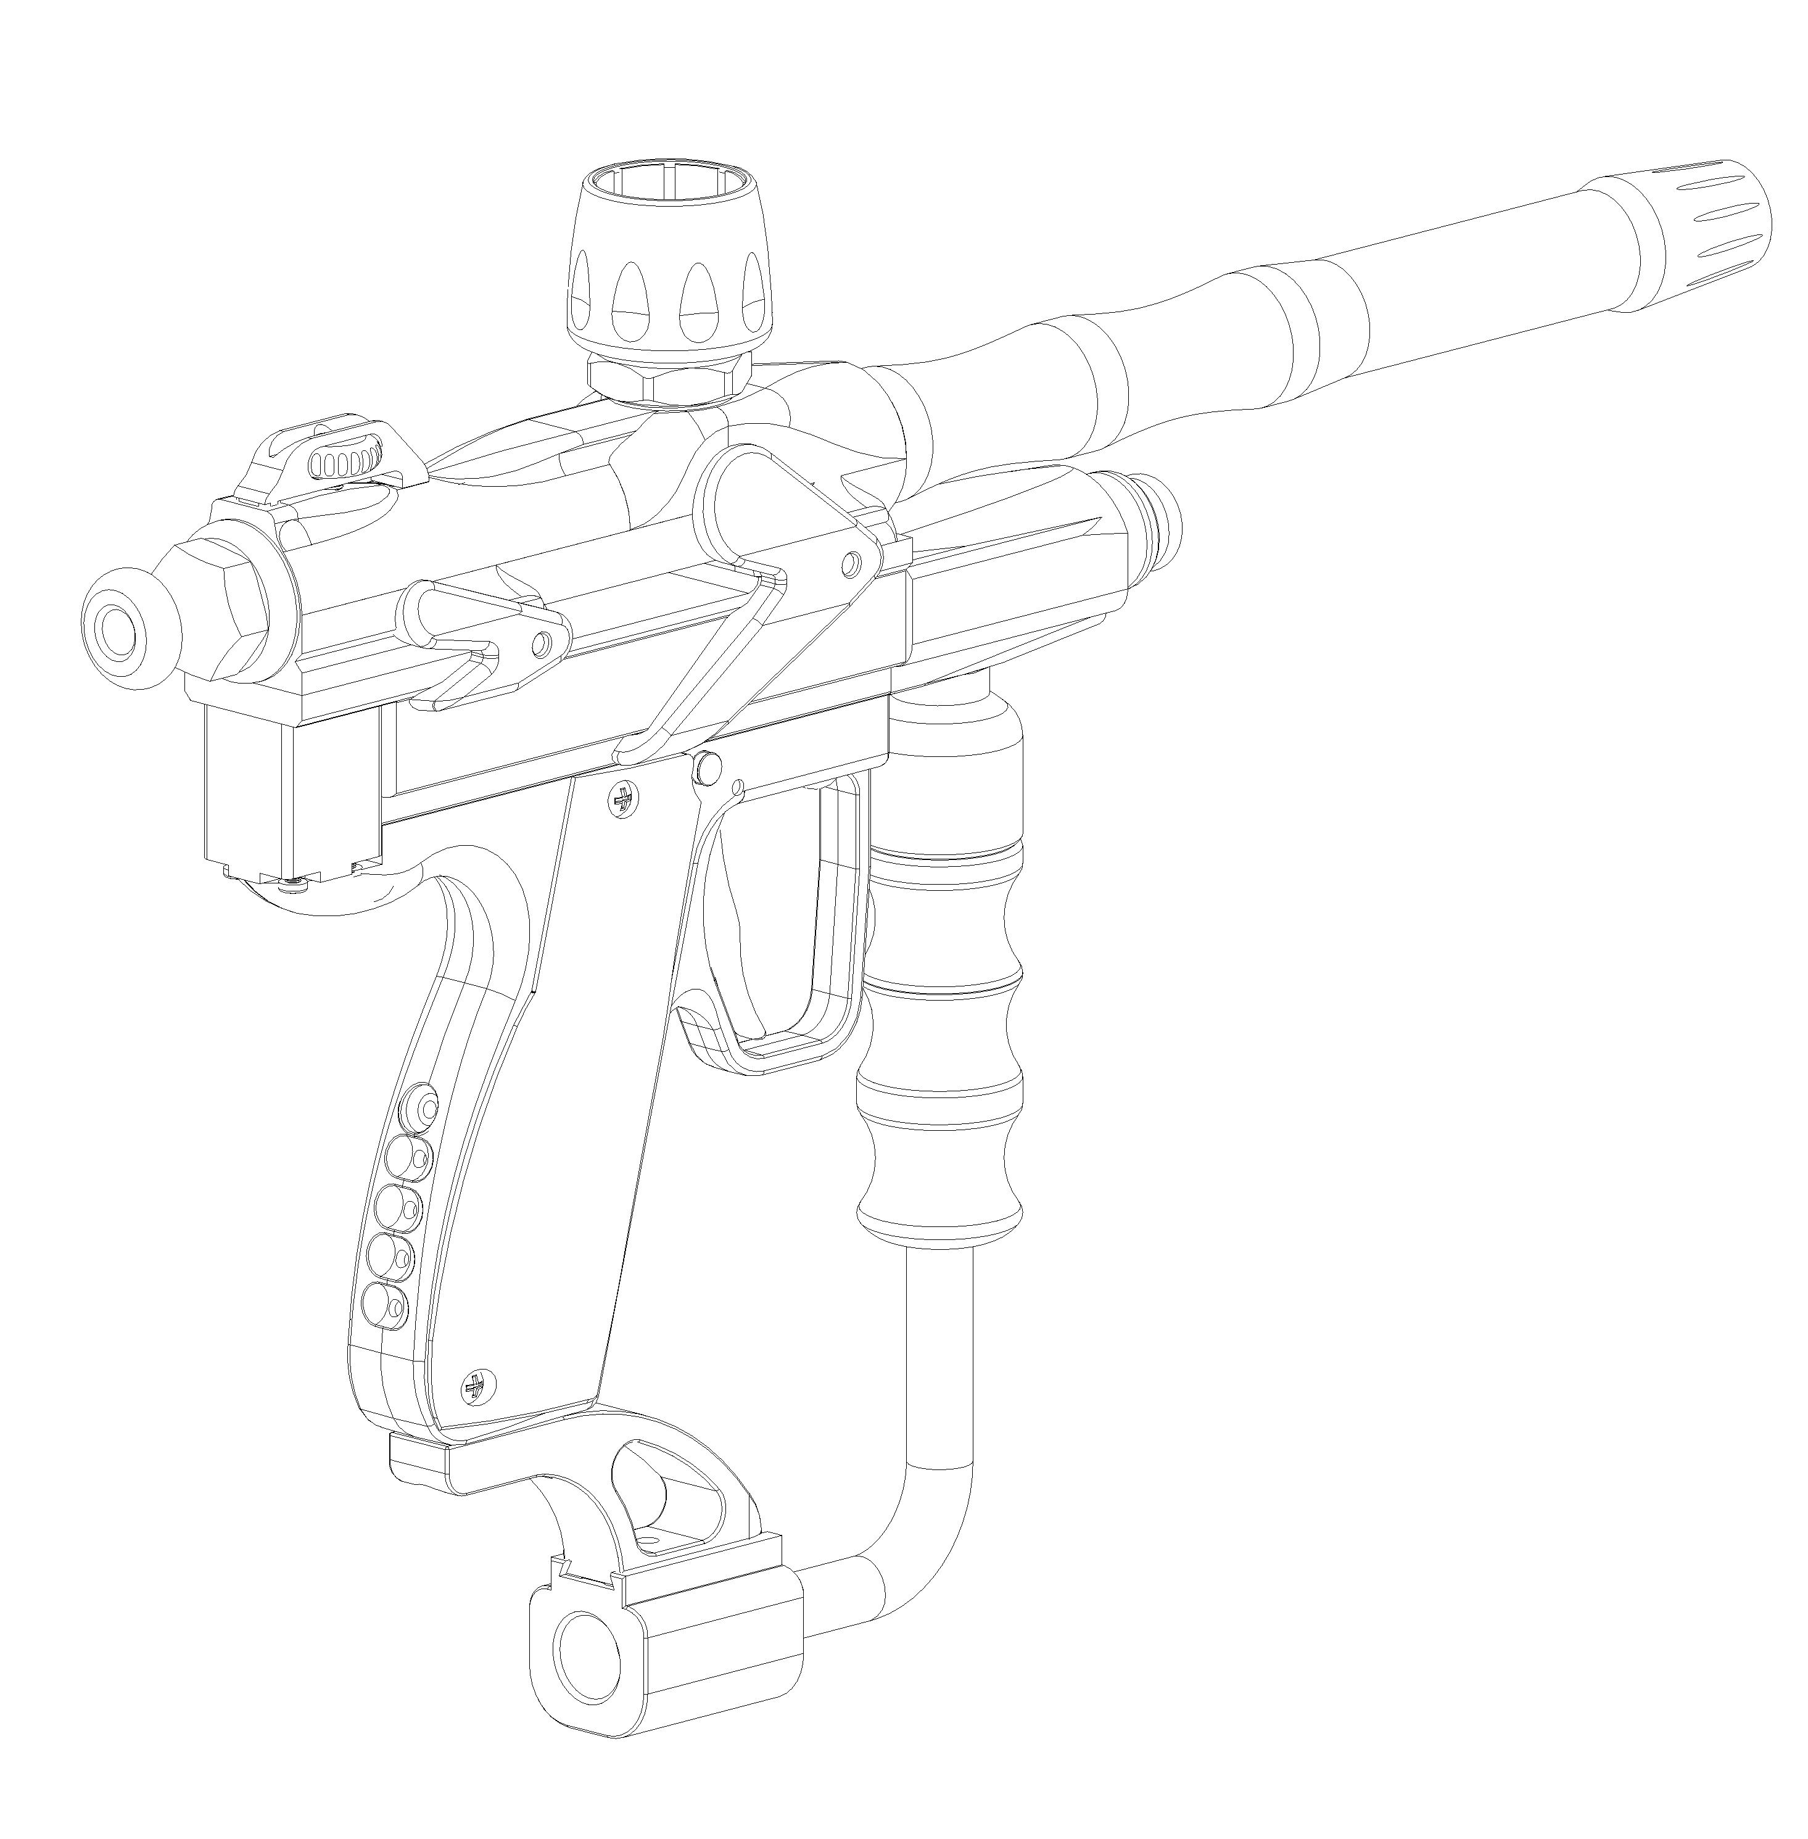
On-Off Switch

LED Indicator

PLEASE NOTE: The battery is not installed initially. Please install the battery by opening the rubber cover at the handle and plugging in the 9V battery. Before installation of the battery, please make sure that the gun is switched off.

Push the on-off switch from the “PUSH SAFE” position to “PUSH FIRE” position. The colour of the LED will indicate the amount of power left in the battery. Please refer to Part 4. Charging The Battery for more information. The frequency of flashing will indicate whether a paintball is detected in the chamber. Please refer to Part 6. Paintball Detector for more information.

3. SETTING UP THE PAINTBALL MARKER

PLEASE NOTE: This function can only be executed when the paintball marker is in PUSH SAFE mode, which means the paintball marker is switched off.
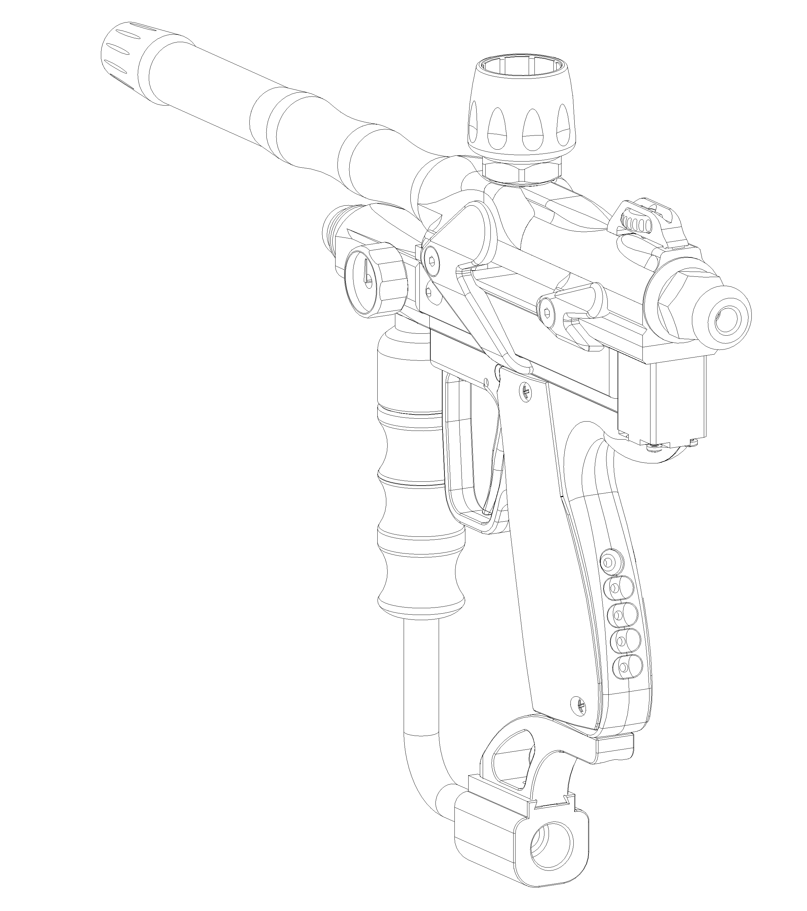
LED Indicator
Button 1
Button 2

Button 3

Mode 1 : Adjusting the number of rounds in each firing cycle. Available values are 1, 2, 3, 4, 5, 6, 7(Continuous). (Default setting is 1.)
Checking : Press Button 2 once when the paintball marker is switched off. The LED will turn red. After 1 second, the LED will start flashing. The number of flashes will indicate the number of rounds for each firing cycle. If the LED flashes once, it means it will fire one round each time. If the LED flashes twice, the paintball marker will fire 2 rounds each time, and so on. If the LED flashes 7 times, it means the paintball marker will fire continuously when the trigger is pressed continuously.
Adjusting : Press Button 2 once when the paintball marker is switched off. The LED will turn red. At the moment when the LED stays on red for one second, press either button 1 or 3, button 1 will increase the number of rounds fired each round, while button 3 will decrease the number of rounds fired. After adjusting, the LED will flash again, which will indicate the number of rounds fired each time.
Mode 2: Adjusting the rate of fire. Available values are 4 to 20 balls per second. (Default setting is 10 balls per second.)

Checking: Press Button 2 twice when the paintball marker is switched off. The LED will turn green. After 1 second, the LED will start flashing. The number of flashes will indicate the rate of fire (ROF). If the LED flashes four times, the rate of fire will be four balls per second. If the LED flashes five times the rate of fire will be five balls per second, and so on.
Adjusting : Press Button 2 twice when the paintball marker is switched off. The LED will turn green. At the moment when the LED stays on green for 1 second, press either button 1 or button 3, button 1 will increase the rate of fire, while button 3 will decrease the rate of fire. After adjusting, the LED will flash again, which will indicate the rate of fire in terms of balls per second.

How to get a suitable rate of fire (ROF) value :

In the single ball firing mode, when the paintball marker only shoots one paintball with each trigger squeeze (Mode 1, value 1), the ROF setting should be higher than the number of times that a certain player is able to squeeze the trigger per second. For example, if a player can squeeze the trigger eight times per second, the ROF value should be set to eight or more to accommodate the speed of the trigger squeeze.
However, the ROF value should be set to a value that is smaller than the feed rate of the paintball loader. This will ensure smooth feeding of paintball during gameplay. A good paintball loader is recommended which has a high feed rate so that higher ROF can be obtained.
When the loader has a low feed rate or when the paintball detector is abnormal, the ROF value should be set to a lower value.

PLEASE NOTE: Mode 1 and mode 2 functions are only available if the jumper on the PCB is plucked in. Under normal conditions there should be no jumpers on the PCB because the semi-auto burst mode and fully automatic mode has been turned off. Please refer to Part 8. Semi-Auto Burst Mode and Automatic Mode for more information.

Mode 3 : Adjusting valve opening time. Available values are from 1 to 12. (Default setting is 7) (Recommended values are from 4 to 8)

Checking : Press Button 2 three times when the paintball marker is switched off. The LED will turn orange. After 1 second, the LED will start flashing. The number of flashes will indicate the valve opening time value.
Adjusting : Press Button 2 three times when the paintball marker is switched off. The LED will turn orange. At the moment when the LED stays on orange for 1 second, press either button 1 or button 3, button 1 will increase the valve opening time, while button 3 will decrease the valve opening time. After adjusting, the LED will flash again, which will indicate the valve opening time.

How to adjust the valve opening time to a suitable value

PLEASE NOTE: Adjusting the valve opening time will affect the accuracy, performance and gas consumption of the paintball marker. If the performance of the marker is unsatisfactory, please re-adjust the valve opening time to seven.

Before adjusting, please ensure that the paintball marker is in a normal condition, check that the O-rings on the pistons are in good condition. Please change the O-rings if they are found to be worn out. Ensure that the piston is maintained by adding a thin layer of synthetic oil on the moving parts. Check that the battery has enough power.

Adjust the velocity of the paintball to a suitable value by turning the screw at the back of the bolt assembly all the way in, and then turn anti-clockwise for one-and-a-half to two complete turns. Please refer to Part 7. Velocity Adjustment for more information.
Make sure the gas cylinder is installed correctly, and the correct pressure is used. Please refer to Part 10. Pressure Setting for more information. Ensure that there is no leak in the entire gas line.

Change the paintball marker to single paintball firing mode. (Mode 1, value 1)
Change the paintball marker valve opening time to 7. (Mode 3, value 7)

Fire the paintball marker by pressing and holding button 3 and pull the trigger. A loud sound can be heard when gas is ejected from the chamber without any paintball. Lower the value until a soft sound can be heard. Increase this value by 1 or 2. (Increase by 2 if a velocity chronograph is not available) Use a velocity chronograph to test the velocity of the paintball. If the velocity of the paintball is found to be unstable, increase the valve opening time value by 1 and repeat the test until the velocity of the paintball is stable.
Mode 4 : Adjusting the reaction delay of the paintball detector. Available values are from 1 to 20. (Default setting is 3) (Recommended values are from 1 to 5)

Checking : Press Button 2 four times when the paintball marker is switched off. The LED will turn red. After 1 second, the LED will start flashing. The number of flashes will indicate the delay time of the paintball detector.
Adjusting : Press Button 2 four times when the paintball marker is switched off. The LED will turn red. At the moment when the LED stays on red for 1 second, press either button 1 or button 3, button 1 will increase the delay, while button 3 will decrease the delay. After adjusting, the LED will flash again, which will indicate the delay time of the paintball detector.

Mode 5 : Switching the paintball detector on or off. (Default setting is on)

Checking : Press Button 2 five times when the paintball marker is switched off. The colour of the LED will indicate whether the paintball detector is on or off. If the LED indicates green, the paintball detector is switched on. If the LED indicates red, the paintball detector is switched off.
Adjusting : Press Button 2 five times when the paintball marker is switched off. After that, press either button 1 or button 3. Button 1 will change the LED indicator to green and the paintball detector is switched on. Button 3 will change the LED indicator to red and the paintball detector is switched off.

4. CHARGING THE BATTERY

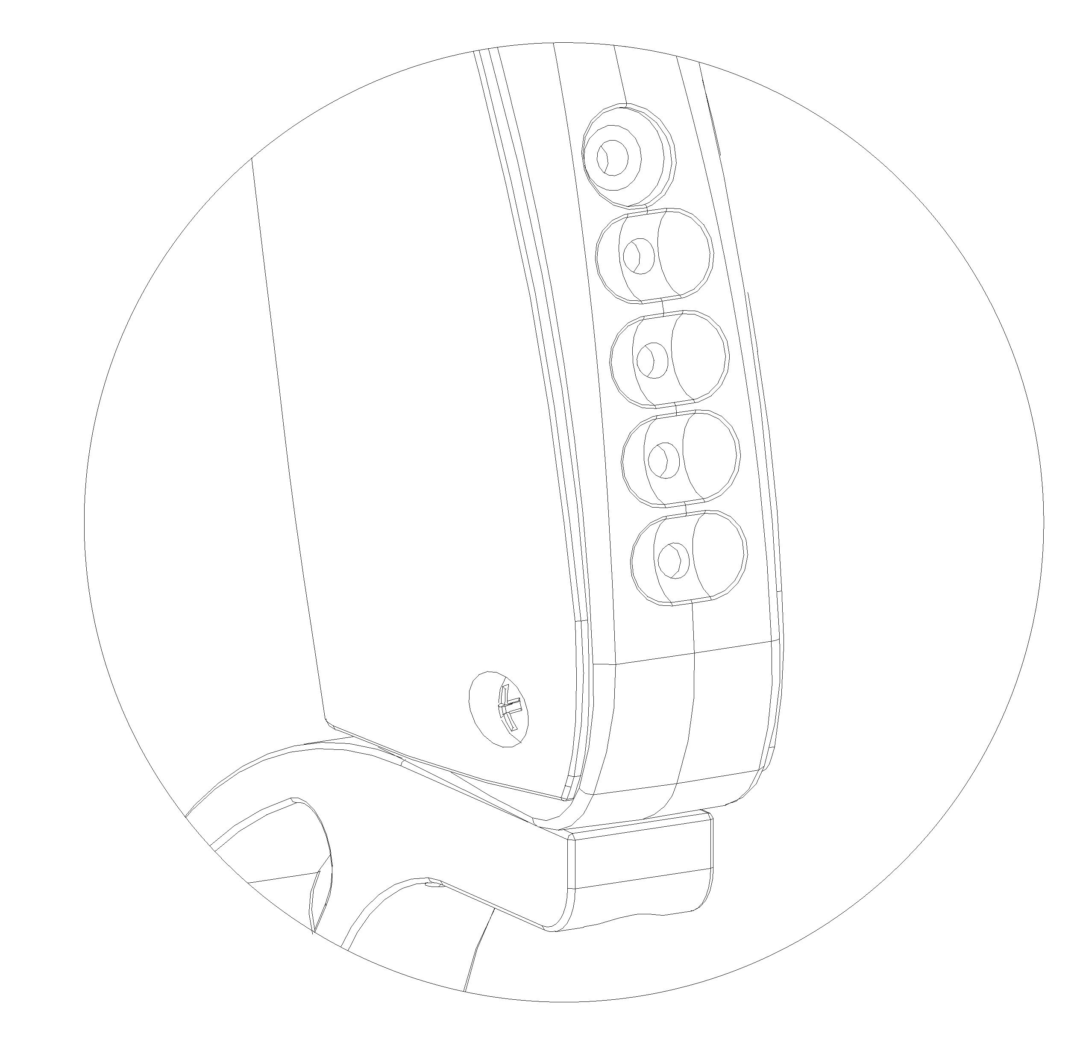
DC Jack for Charging

A 9V NiMH Rechargeable battery is installed in the paintball marker. The paintball marker is also designed to use a 9V alkaline battery.

PLEASE NOTE: It is recommended that users charge up the battery if the paintball markers are left unused for more than 2 weeks. It is necessary to recharge the battery if it has been left unused for more than 3 months.

The paintball marker has a built-in charger. It only requires a DC input of 12 V. The charging operation can be done any time, but it is recommended that charging should be done when the paintball marker is switched off and it is in safe mode. First, plug the adaptor into the socket (or if the paintball marker comes with a cigar light adaptor, plug the adaptor into the socket located in most motor vehicles, the red light on the adaptor will indicate if power is present). Then plug the other end of the adaptor into the charging port of the paintball marker, as shown above. After plugging in all the connections, press any button to activate charging. The LED will indicate the power present in the paintball marker.

PLEASE NOTE: If during charging, there is a power failure, the charging cycle will be interrupted. Please re-activate the charging cycle by pressing any of the buttons after plugging in all the connections again.
When the LED is red, the battery has very low power. Please charge the battery as soon as possible as the battery will be damaged easily if it is uncharged for too long.
When the LED is flashing red, the power is only about 0% – 25%, and the battery requires charging.
When the LED is flashing red and green alternately, the power of the battery is about 25% - 50%.
When the LED is flashing in green, the power of the battery is 50% - 100%.
When the LED is green, the battery is fully charged.
If the LED does not light up and the charging process does not start, remove the DC jack from the charging port on the paintball marker side, and plug it into the charging port again.

PLEASE NOTE: when the LED is red, indicating very low power in the battery, the paintball marker can still be switched on. However, it will automatically shut off within 20 seconds. If the paintball marker is on for more than half an hour without firing, it will shut down by itself. Please push the ON-OFF Switch from the “PUSH FIRE” mode to the “PUSH SAFE” mode to save battery power.

Changing the charging time

Under normal circumstances, the full charging cycle will take about 10 hours. The flashing LED will indicate that the battery is charging. The LED will flash at the rate of 3 times per second, indicating normal charging.

However, the charging time can be increased or decreased. During charging, if button 1 is pressed once, the LED will flash faster, at the rate of 6 times per second, and the charging time is reduced to 5 hours. If button 1 is pressed twice, the LED will flash even faster, at the rate of 12 times per second, and the charging time is reduced to 2.5 hours. Pressing button 3 can increase the charging time, from 2.5 hours to 5 hours and back to 10 hours, which is normal charging.

PLEASE NOTE: It is always recommended to use the normal charging method as this prolongs the battery life. Shortening the charging time will reduce the battery life in the long run.

Charging Port Specification
Input Power : DC 12 – 15 V, internal +, external –
DC Jack : OD 3.5mm, ID 1.3mm

5. ADDITIONAL FUNCTIONS

LED Indicator
Button 1
Button 2

Button 3

To restore factory settings, when the power is switched off, press button 1 and button 3 together for 3 seconds, the LED will flash once, and the factory settings are restored.

To find out the power of the battery when the power is switched off, hold button 1 continuously, the flashing of the LED will indicate the battery power. Please refer to Part 4. Charging the Battery for more information.

To fire the paintball marker without any paintball in the chamber, press and hold button 3 and then press the trigger. This is useful for testing or cleaning the paintball marker, or during cylinder changing.

PLEASE NOTE: During these procedures, please observe all safety procedures.

6. PAINTBALL DETECTOR

Paintball detected : The LED will flash slowly at a rate of 3 times per second.
Paintball not detected : The LED will flash rapidly at a rate of 6 times per second.

PLEASE NOTE : If the paintball detector is switched off, the LED will flash at a rate of 3 times per second as well.

Normally, when there are no more paintballs in the chamber, the trigger would not fire and the LED will flash rapidly. The trigger can only fire when there is a paintball inside the chamber. However, in special or abnormal circumstances, when there is dirt that blocks the detector, or sunlight can shine directly into the feed port when the loader is removed, disrupting the detector, the LED will flash slowly, and the trigger is able to fire. In this case, please switch off the paintball marker and clean the feed port if there is dirt, or install the paintball loader inside the feed port to rectify the situation.

7. VELOCITY ADJUSTMENT

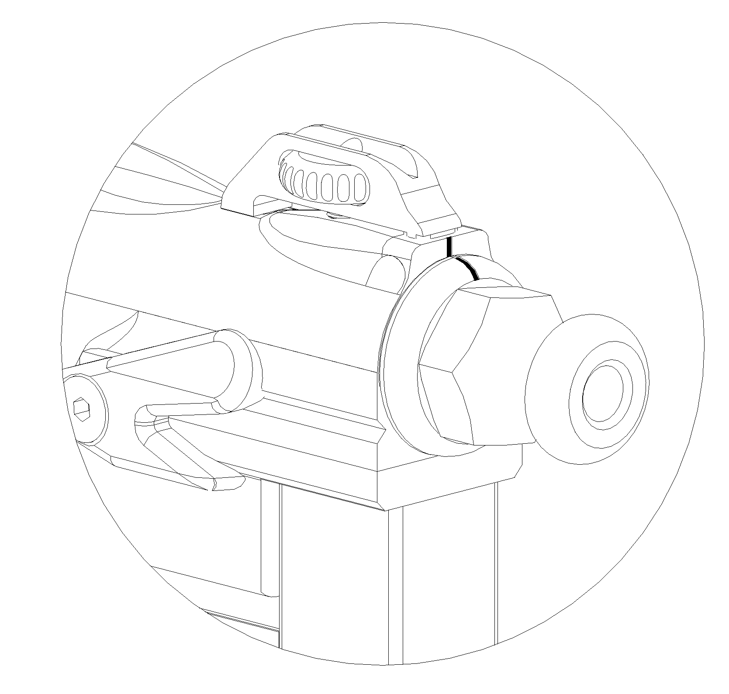
Velocity Adjusting Screw

Use a screwdriver and turn the screw all the way clockwise. Then, turn the screw anti-clockwise by one-and-a-half to two complete turns. Use a chronograph to check and fine tune the velocity of the paintball. Turning anti-clockwise will increase the velocity while turning clockwise will decrease the velocity. The correct setting should be about 250 to 300 feet per second.
8. SEMI-AUTO BURST MODE AND AUTOMATIC MODE

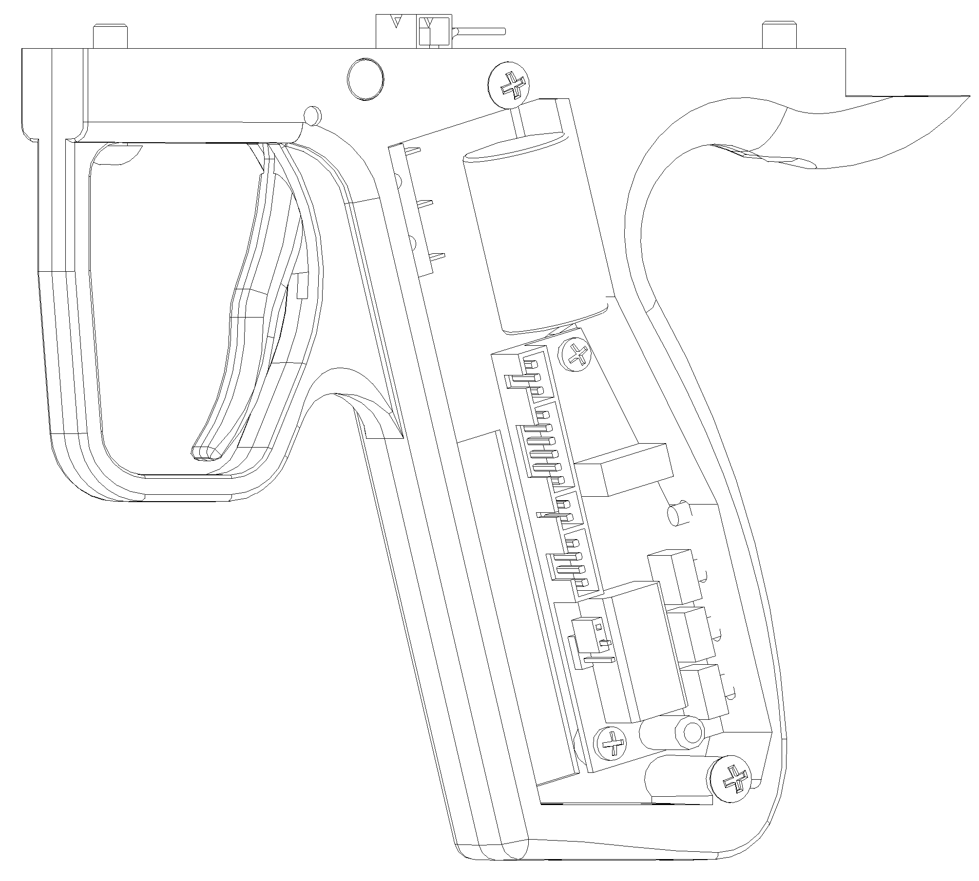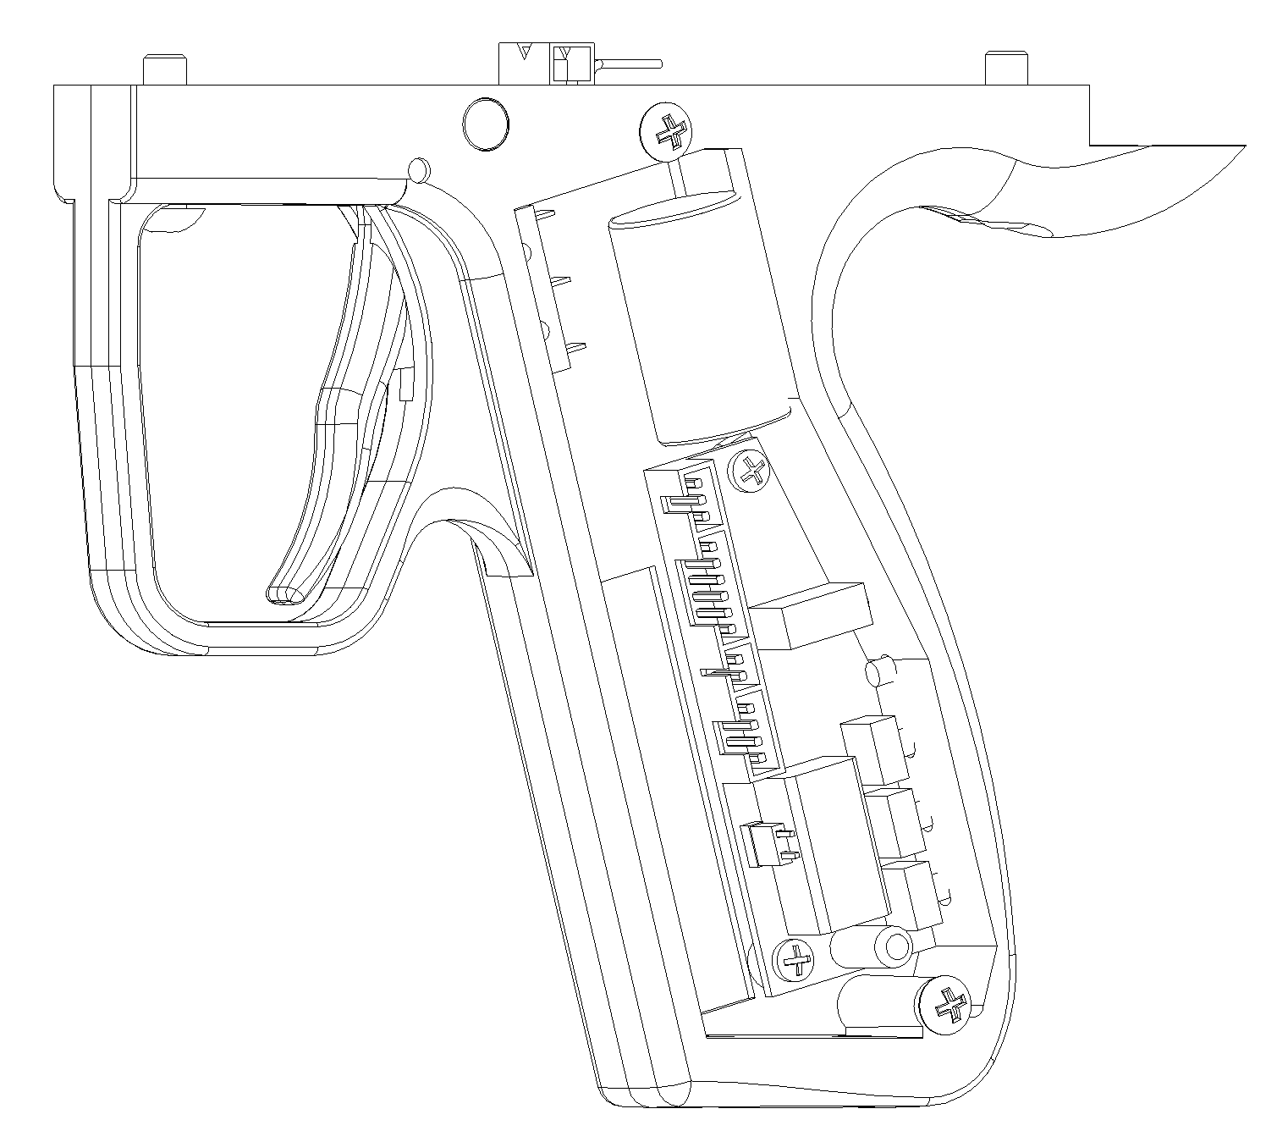

Single Shot Only
Multiple Shots and Auto Mode Available

This marker is suitable for tournaments, where the electronic firing system has to be locked so that it cannot be adjusted. The gun does not have a jumper by default and therefore it is locked into single shot mode.

Without the jumper, the marker can only fire one single shot with one trigger pull, all semi-auto modes (burst mode) and automatic mode are disabled. This function is useful during tournaments when electronic firing system has to be locked according to the rules.

To switch on semi-auto burst mode and automatic mode, please switch off the marker first. Open the trigger cover by loosening the two screws on the left of the trigger assembly. Plug in the jumper as shown in the diagram so that 2 of the pins are being shorted. Close the trigger cover and secure the screws.

9. GAS SUPPLY

This paintball marker is designed to operate on compressed air as well as nitrogen. For JBS-108, carbon dioxide can be used as well.

- Carbon Dioxide (CO₂)： Suitable (Only for JBS-108)
- Compressed Air： Suitable (For JBS-102, JBS-106 and JBS-108)
- Nitrogen (N₂)： Suitable (For JBS-102, JBS-106 and JBS-108)

10. PRESSURE SETTING

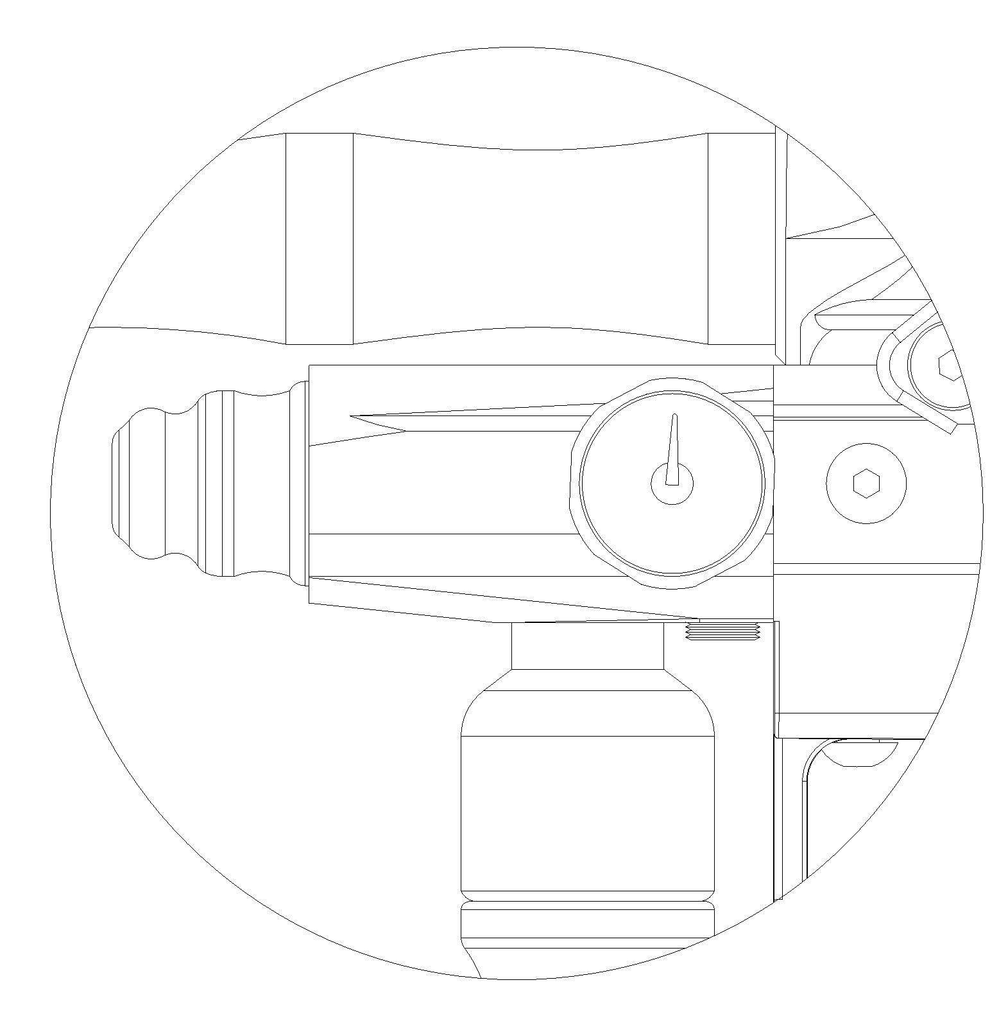
Pressure Relief Valve at 250 psi
Allen Screw
Pressure Gauge

Turn the allen screw to adjust the firing pressure of the paintball marker. The recommended pressure is 180 to 200 psi. A pressure relief valve is located as above for safety and is set at 250 psi.

11. CHANGING THE GAS CYLINDER

The normal shooting pressure should be 180 to 200 psi, as indicated by the pressure gauge. If the pressure has dropped to 150 to 160 psi, the gas cylinder needs to be charged up or changed.

- Change cylinders at safe areas only.
- Wear all protective gears and follow all the safety instructions.
- Ensure that there are no paintballs inside the chamber and loader.
- Close the valve on the air cylinder.
- Discharge the paintball marker of any residual pressure by firing with the barrel pointing in a safe direction. This can be done by pressing and holding button 3 and then squeezing the trigger repeatedly until all the pressure is relieved.
- Turn the velocity adjusting screw clockwise all the way until it is tightened.
- The gas cylinder can now be replaced.
- After replacing the cylinder, please re-adjust the velocity of the paintball again. Please refer to Part 7. Velocity Adjustment for more information.

12. CHANGING THE SOLENOID

If the solenoid has been disassembled, please note the following when assembling back the solenoid:

Ensure that the solenoid is secured to the paintball marker base evenly.

Assemble the marker first. Do not connect any gas cylinder or loader. Reset the original solenoid position by switching on the marker, and firing with the barrel pointing in a safe direction. This can be done by pressing and holding button 3 and then squeezing the trigger.

13. MAINTENANCE

Button 3
Bolt and Piston Assembly
Knob

- Close the cylinder.

- Press and hold button 3, and activate the trigger. Ensure the gas trapped inside the chambers is ejected. Ensure that the barrel is pointing in a safe direction.

- Turn the knob anticlockwise while holding the bolt and piston assembly. When the knob is loosened for a few turns, the bolt and piston assembly will be ejected automatically. Strip the bolt and piston assembly and clean all individual parts. Replace any damaged O-rings or oil seals. Lubricate the piston and seals with synthetic oil only. DO NOT use any oils or products containing hydrocarbons as this will damage the O-rings and oil seals.

Please ensure that this hole is not covered
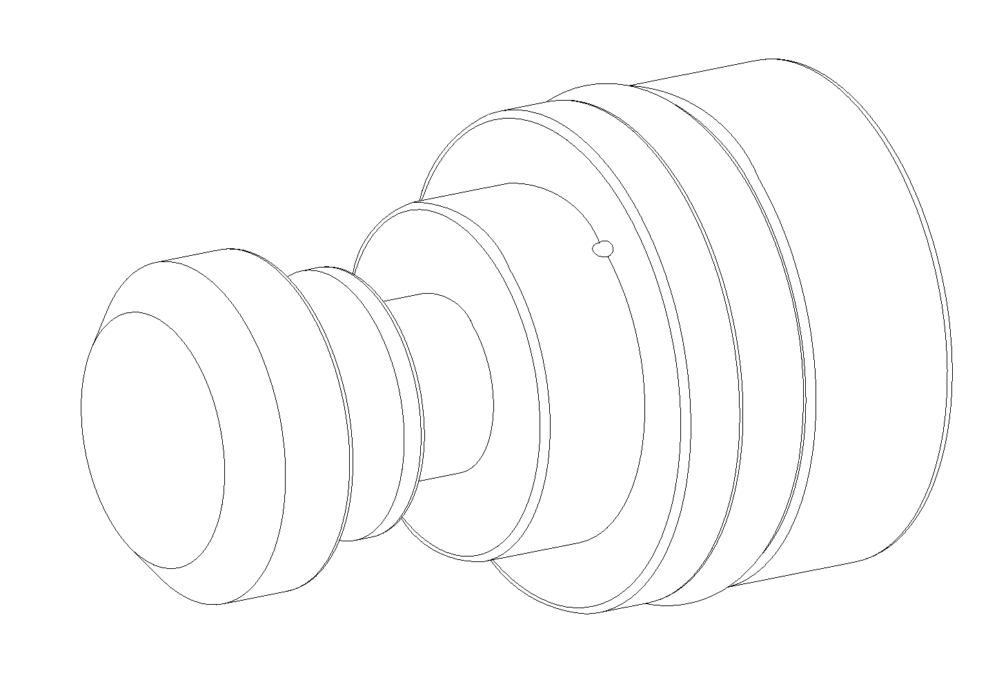

- During lubrication of the piston O-ring, please ensure that the small hole at the piston is not covered by any synthetic oil or silicon grease. The performance of the paintball marker will be affected if the hole is not clear.

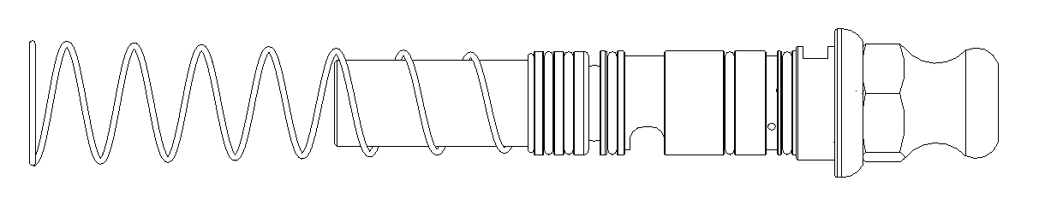
Please ensure that this part is tight-fitted
This spring end has a smaller diameter



- Please ensure that the spring is installed in the correct manner and direction. If installed correctly, the spring and the piston assembly should be fitted tightly. If the spring and the piston assembly are loose, this indicates that the spring has been installed incorrectly. In this case, disassemble and reverse the direction of the spring.

Marking

- Please ensure that the marking above is aligned during assembly.
14. TROUBLESHOOTING

The paintball marker cannot fire

Is there air, N₂ or CO₂ present in the paintball marker?
- Please check that the gas cylinder is connected correctly, and that the gas cylinder valve is open, and has at least 250 psi of pressure inside the gas cylinder. Please refer to Part 11. Changing Cylinder for more information.

Is the low pressure regulator set correctly?
- Please check that the low pressure regulator gauge is at 200 psi. Please refer to Part 10. Pressure Setting for more information.

Is the paintball marker on?
- Please check if the LED at the handle of the paintball marker is flashing. If it is not flashing, the paintball marker is switched off. To switch on the paintball marker, please refer to Part 2. Switching on the Paintball Marker for more information.

Is the battery charged?
- When the marker is switched off, press and hold button 1, the LED will indicate the battery power that is present in the marker. Please refer to Part 5. Additional Functions for more information. If the battery needs to be recharged, please refer to Part 4. Charging the Battery for more information.

Are all the connections plugged in at the PCB?
- Please loosen and take out the 2 screws at the handle cover, and check that all the four connections are plugged into the PCB. Please make sure that the battery is connected to the PCB as well.

Is the trigger adjusted correctly?
- The trigger sensitivity can be adjusted when the handle is disassembled. However, the trigger may be adjusted wrongly. To check if the trigger is adjusted correctly, please switch off the paintball marker first. Squeeze the trigger (make sure the paintball marker is pointing at a safe direction) and check if the micro switch is activated as the trigger is squeezed. If the sound of the micro switch is heard, the trigger is adjusted correctly.

Is the bolt jammed?
- Please refer to Part 13. Maintenance for more information.

Is the paintball detector on?
- When the paintball detector is on, and there is no paintball inside the chamber, the paintball marker will be unable to fire. Please refer to Part 6. Paintball Detector for more information.

The velocity of the paintball is too high or too low.
- Please check that the low pressure regulator gauge is at 200 psi. Please refer to Part 10. Pressure Setting for more information.
- The valve opening time of the solenoid may affect the velocity of paintball. Please refer to Part 3. Setting Up the Paintball Marker for more information.
- To adjust the velocity of the paintball, please refer Part 7. Velocity Adjustment for more information

The paintball marker is chopping paintballs.
- Please check the rate of fire (ROF) of the paintball marker. Ensure that the value of ROF of the paintball marker is smaller than the feeding rate of the paintball loader. Please refer to Part 2. Setting Up the Paintball Marker for more information.
- Please check that the rubber cushion is present at the bolt end and the two ball detents are present at the paintball marker. The ball detents are located below both the paintball detector covers.
- Please ensure that the paintballs being used are of good quality. The quality, size and roundness will determine whether the paintball markers will chop paintball. This paintball marker uses .68 calibre of paintball only.
- Please note that the weather will affect the performance of the paintball marker as well because the paintball may freeze and break easily at low temperature. (less than 15ºC)

The paintball marker is making excessive noise or having excessive gas consumption.
- Please check that the low pressure regulator gauge is at 200 psi. Please refer to Part 10. Pressure Setting for more information.
- Please adjust the valve opening time of the solenoid to a suitable value. Please refer to Part 3. Setting Up the Paintball Marker for more information.
- Please ensure that all the O-rings in the paintball markers are in good conditions.

There is gas leaking at the paintball marker.
- Please ensure that all the O-rings in the paintball markers are in good conditions.
- Please check that all the gas connections at the paintball marker.
- If gas is found to be rushing through the barrel when the gas cylinder valve is open, please close the cylinder valve and turn the velocity adjusting screw clockwise until it is tightened. Open the gas cylinder valve and adjust the velocity of the paintball again. Please refer to Part 7. Velocity Adjustment for more information.

15. PRODUCT SPECIFICATION

Weight | 1.4 kg (3.1 lb)
Length with barrel | 460mm (18.1 inch)
Length without barrel | 260mm (10.2 inch)
Gas Supply | N₂ / Air
Working Pressure | 200 psi
Type of Paintball | .68 calibre paintball
Velocity of Paintball | 300 feet per second
Rate of Fire | 4 to 20 balls per second
Battery | 9V NiMH Rechargeable Battery  9V Alkaline Battery

